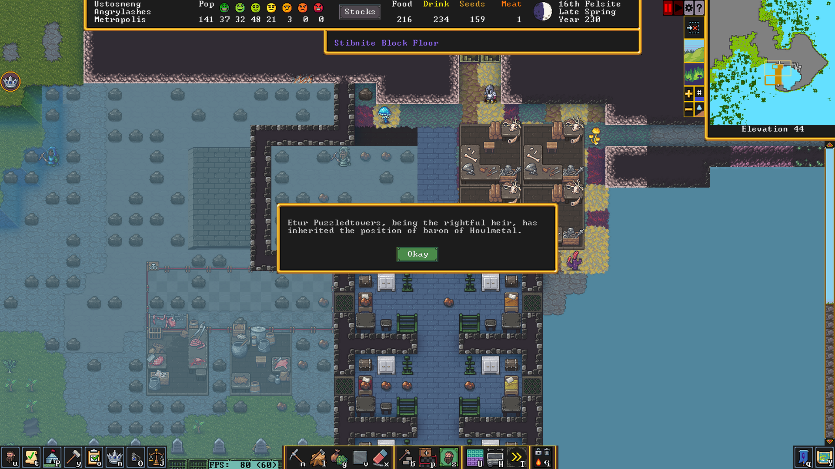Just what I needed, another noble. This takes the count up to 5 Baronesses.

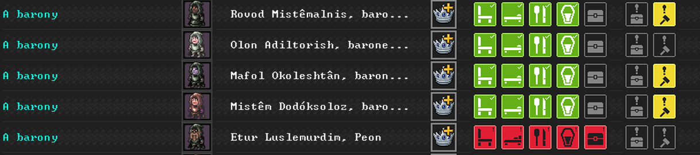
The only one I care about is Mafol, since she is the Baroness of Angrylashes. The rest hold titles without power. They are long lost relatives from lost or abandoned sites.
For example:

Who claimed the title in:
Once the former holder, her mother, passed away:
The great baroness of a fort lost to a Forgotten beat over 100 years ago!

Or how about:
The might fortress
Currently the enemy base of operation in an ongoing goblin invasion on the dwarven lands by our sworn enemies - the goblin nation of the Flies of Ringing, with over 83 warriors strong (125 at the begging of our recent attack).

There is also:
No idea what that place is, probably nowhere important.
Yup, some worthless backwater. Nothing exciting happened there since some trolls caused noise in 165.

And then there is Mafol the great:
One of the first naturally born dwarves.

Actually, it just hit me that this new guy is the first Baron (as in male) in my fort
Recently lost his wife in a goblin attack on Bootbegin
He was traveling when she died. I guess there was no point going bck there, so he came to Angrylashes instead.

10th obsidian 229, Raid on Fedochre - the forces of Angrylashes entered and searched Fedochre which belongs to the Oceanic Heathers, this was an attempt to recover the stolen Mug or possibly gain intel on it's location.
Attack on Lashman
11th Granite 230 - forces of Angrylashes attacked Lashman, many kills but no casualties among the attackers
The elven tribute.
Oceanic Heathers – the elven civilization connected to Mothsubmerged
on 17th Slate 230 tribute was secured between Mothsubmerged and Angrylashes
2nd Felsite – forces of Angrylashes attacked Hailtakers controlled by the flies. Killed 1 elf and caused some damage.

